**Lab Exercise 1**

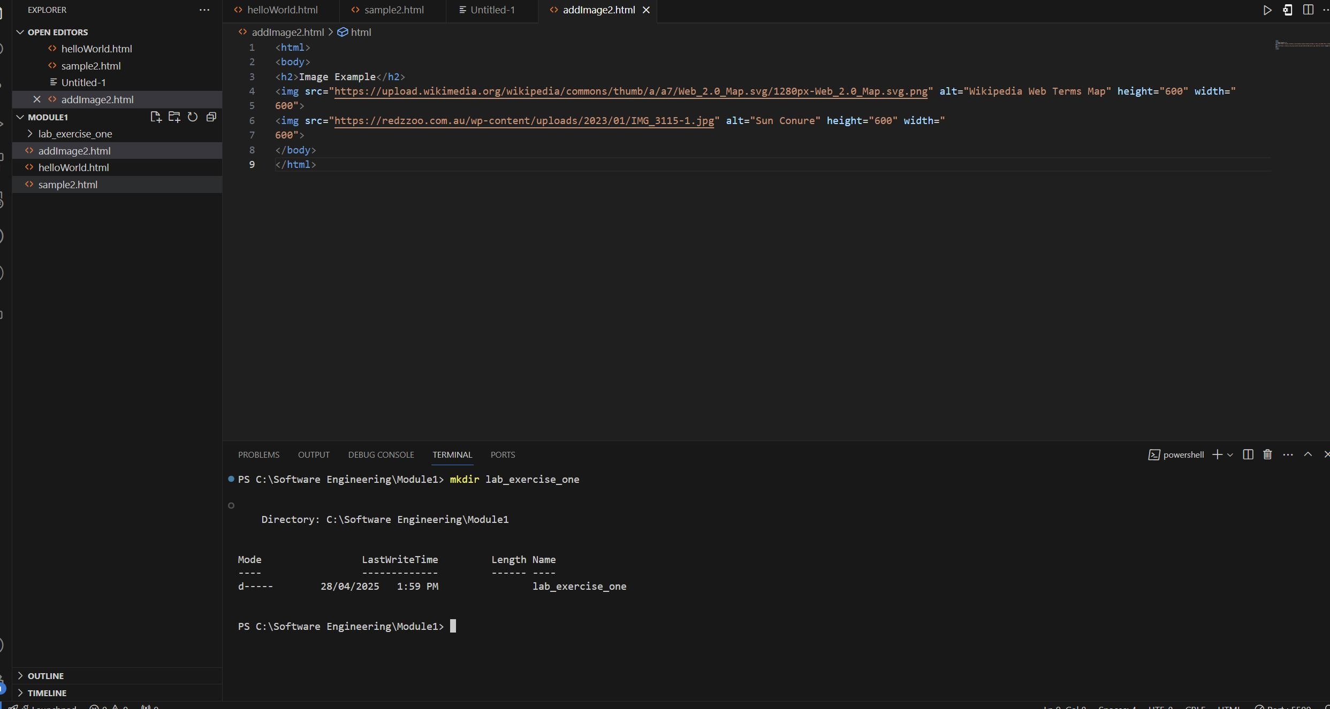**Step 1: Creation of folder one**

**Step 2:Navigation into new folder and creation of second folder**

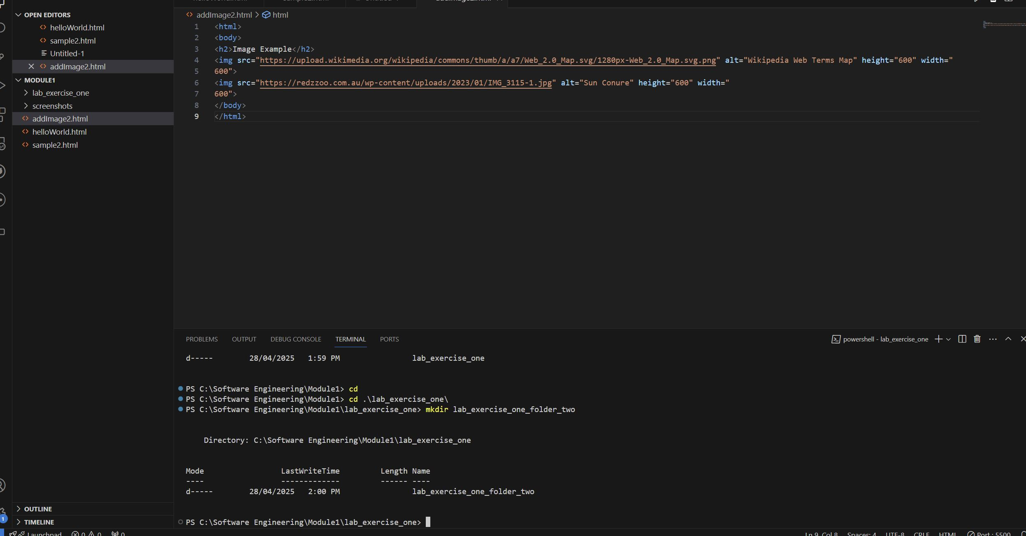

**Step 3: Print contents of 1st folder**

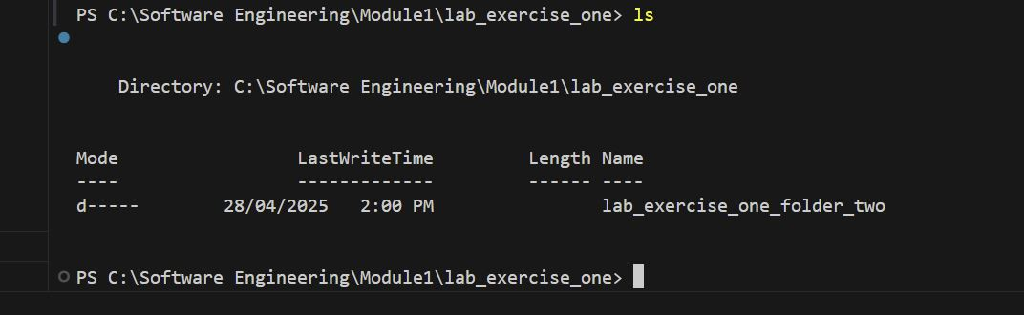

**Step 4: Navigation to second folder and printing of file path**

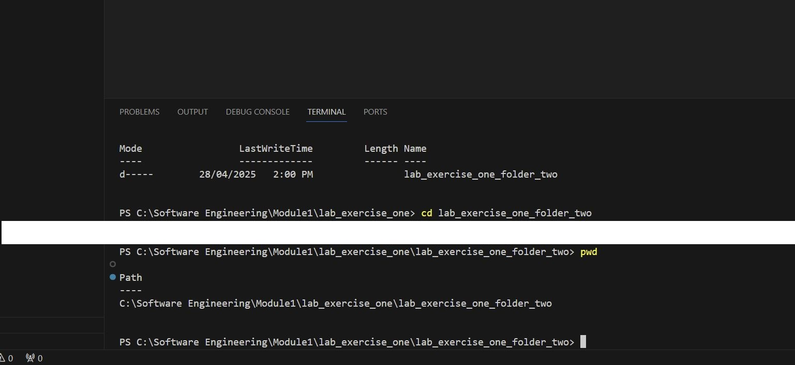

**Step 5: Navigation to folder module 1 and lab exercise 1**

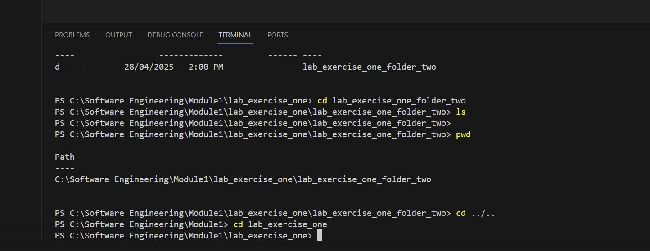

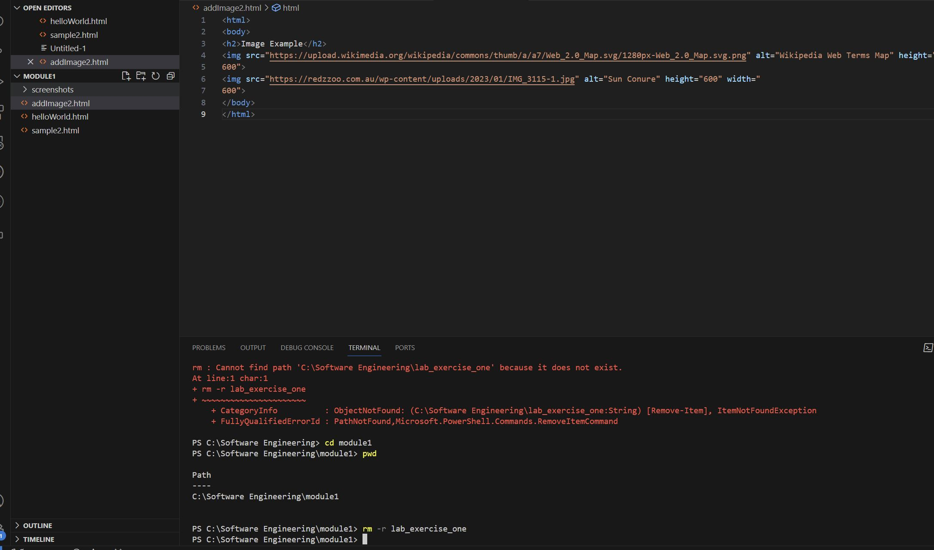**Step 6: Deletion of lab exercise 1 folder**